HOUSING SIGN UPS | Step by Step Instructions

Table of Contents
I. | Room Retention | 2-5
II. | Same Floor/New Room | 6-11
III. | General Housing Selection; New Room/New Floor | 12-17
IV. | Roommate Pull In | 18-22
V. | Roommate PIN | 23-24

ROOM RETENTION
STEP 1: LOG IN FROM myMOODY PORTAL BY CLICKING ON CAMPUS HOUSING UNDER THE RESIDENCE LIFE HEADING
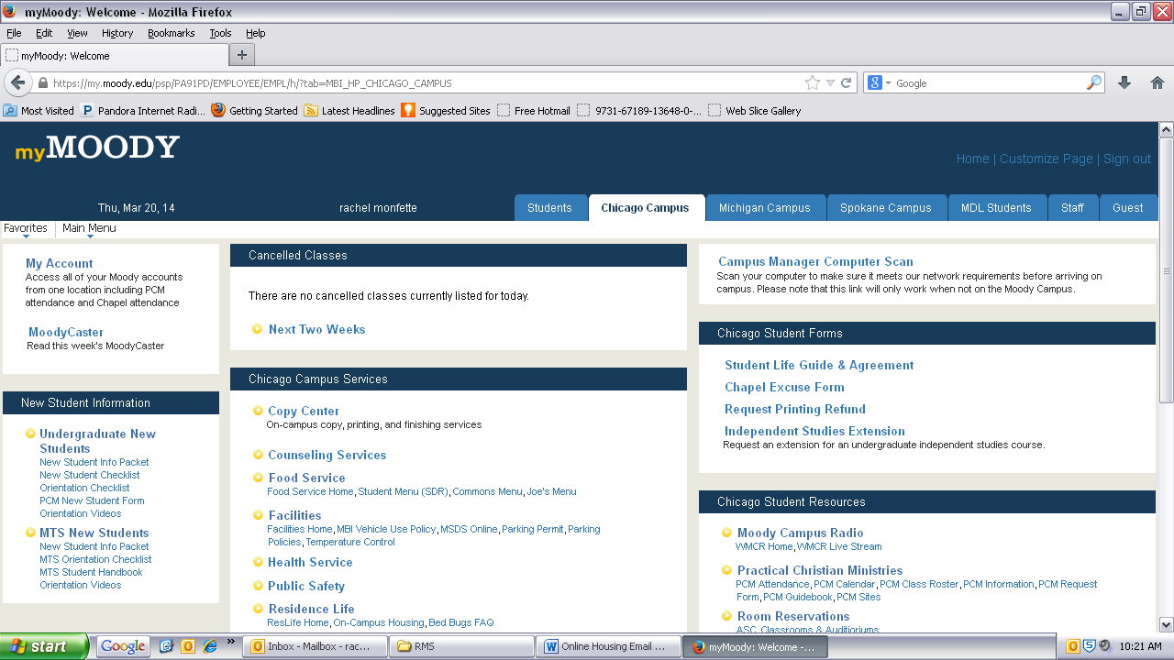

STEP 2: CLICK Housing Selection Main Menu in the center of the page.
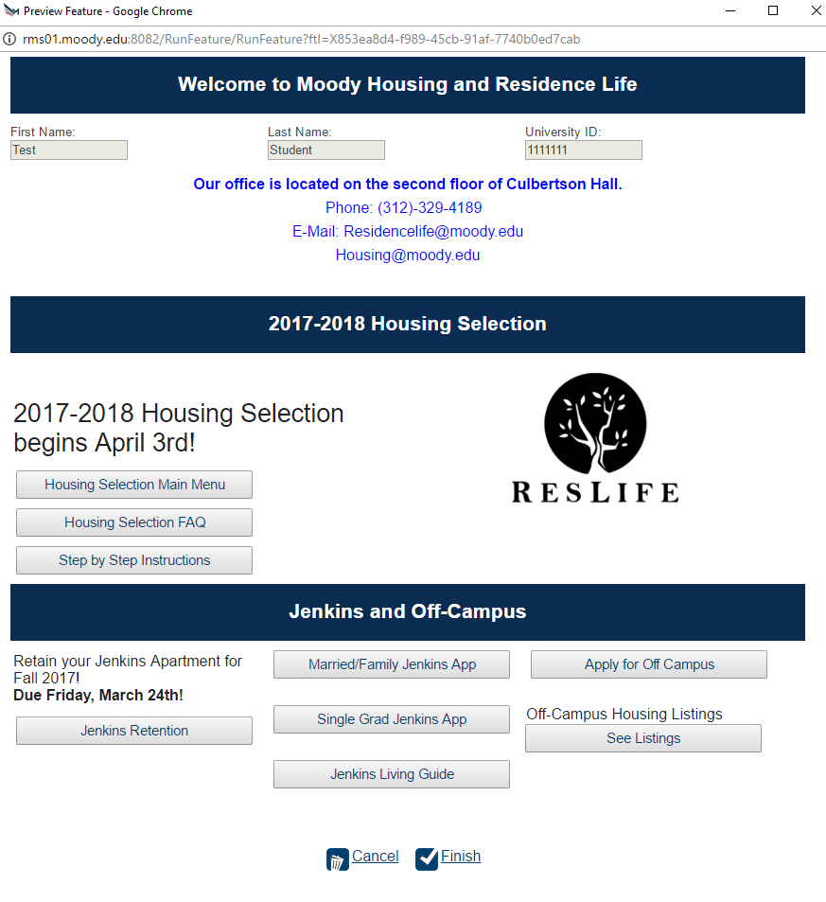

STEP 3: Once you get to the Housing Selection Main Menu, select “Retain Your Current Room”.
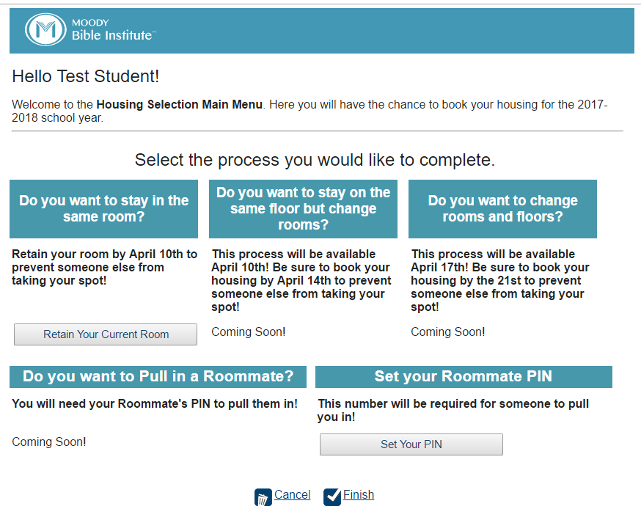
STEP 4: CLICK RETAIN YOUR ROOM and then select NEXT STEP 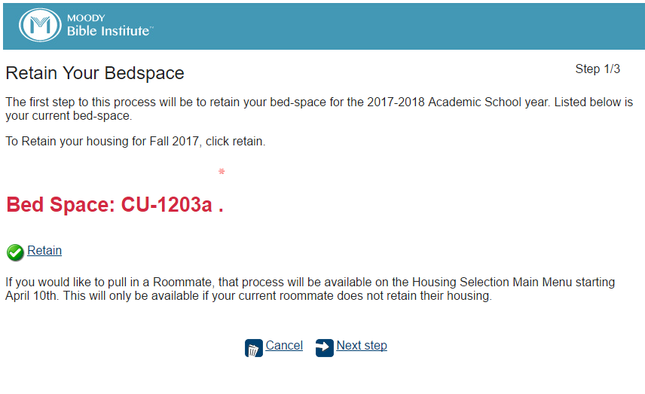
STEP 5: To register for your meal plan, click the Green Plus Sign to see Plan Details. Then click Plan Type and select Meal. A list of meal plans will then become available in the Plan Drop down menu. To select a plan, click Add Meal Plan. This is required. Email Foodservice@moody.edu if you qualify for an exemption.
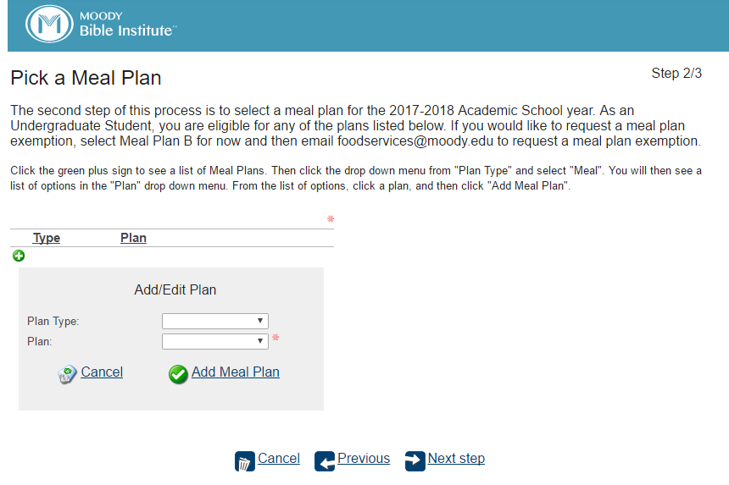
STEP 6: Review and Confirm. This process will not be complete until you click the FINISH button! You can also email or download a copy of your process summary for your records. 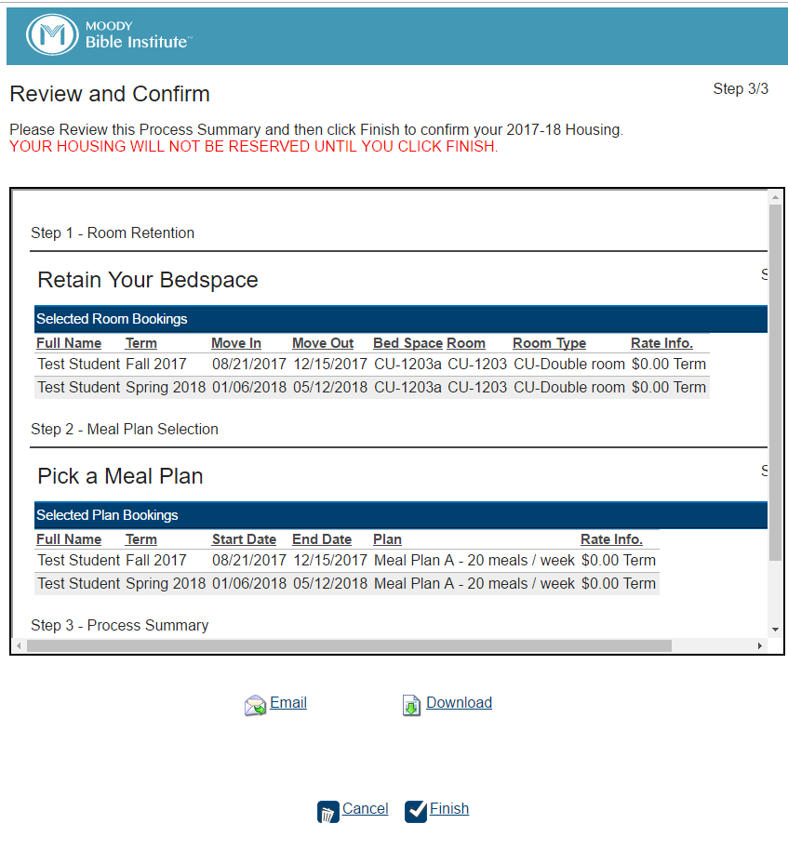

SAME FLOOR/NEW ROOM
STEP 1: LOG IN FROM myMOODY PORTAL BY CLICKING ON CAMPUS HOUSING UNDER THE RESIDENCE LIFE HEADING

STEP 2: CLICK Housing Selection Main Menu in the center of the page.

STEP 3: Once you get to the Housing Selection Main Menu, click SAME FLOOR/NEW ROOM.
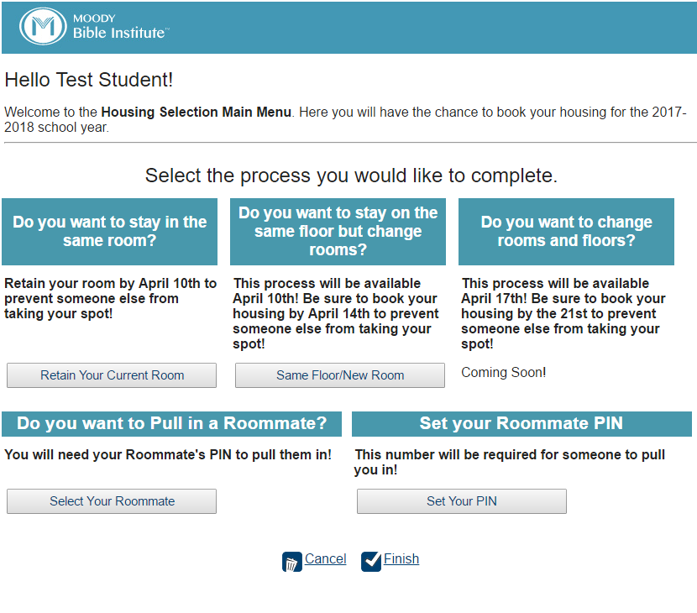
STEP 4: Confirm the Term Dates by clicking NEXT STEP 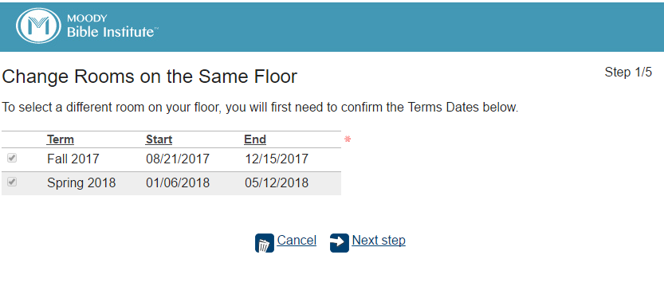

STEP 5: This step is not required. To skip this step, click NEXT STEP. To Select a Roommate, click the Green Plus Sign. Type in your Roommates First and Last name, or their ID, and click SEARCH. In order to select your roommate, you will need to input their Roommate PIN (CAPS apply). Then click SELECT and NEXT STEP.
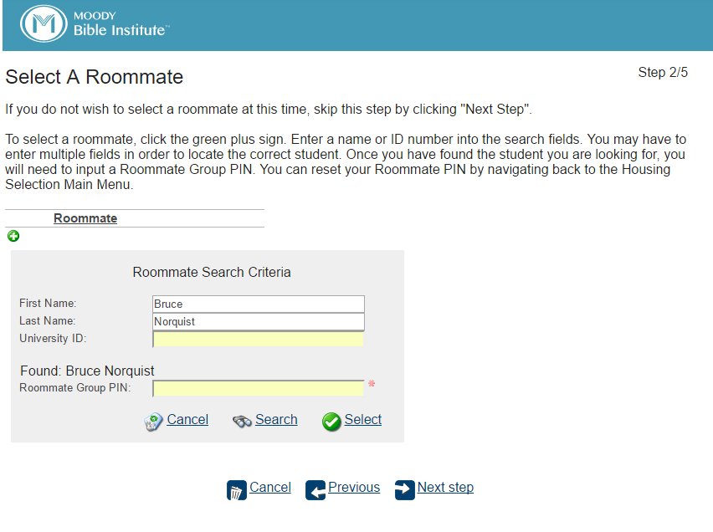

STEP 6: Click the ROOM TYPE Dropdown Menu. This will show your options based on information you have input. If you input two roommates, you will only see Triple rooms available. If you input one roommate, you will only see Doubles. Select the ROOM TYPE and click SEARCH. Then click the links under AVAILABLE ROOMS BY LIVING AREA to show available options. To see additional details, you can click on the room. To LOCK a bedspace, click the LOCK ICON. Then add each Roommate to a Bed-Space and click NEXT STEP.
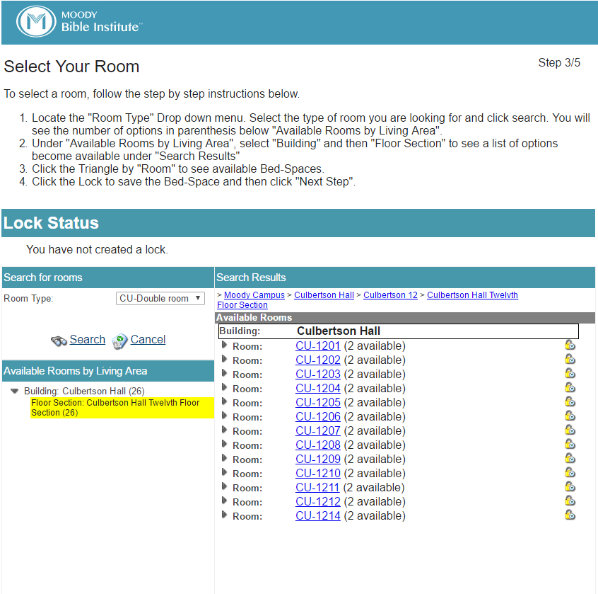
STEP 7: Register for your meal plans, click the Green Plus Sign to see Plan Details. Then click Plan Type and select Meal. A list of meal plans will then become available in the Plan Drop down menu. To select a plan, click Add Meal Plan. This is required. Email Foodservice@moody.edu if you qualify for an exemption. 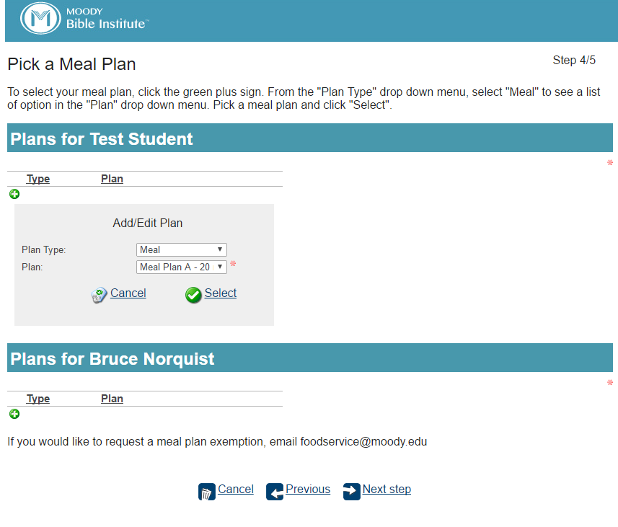

STEP 8: Review and Confirm. This process will not be complete until you click the FINISH button! You can also email or download a copy of your process summary for your records.

GENERAL SELECTION; NEW FLOOR/NEW ROOM
STEP 1: LOG IN FROM myMOODY PORTAL BY CLICKING ON CAMPUS HOUSING UNDER THE RESIDENCE LIFE HEADING

STEP 2: CLICK Housing Selection Main Menu in the center of the page.

STEP 3: Once you get to the Housing Selection Main Menu, click NEW FLOOR/NEW ROOM.
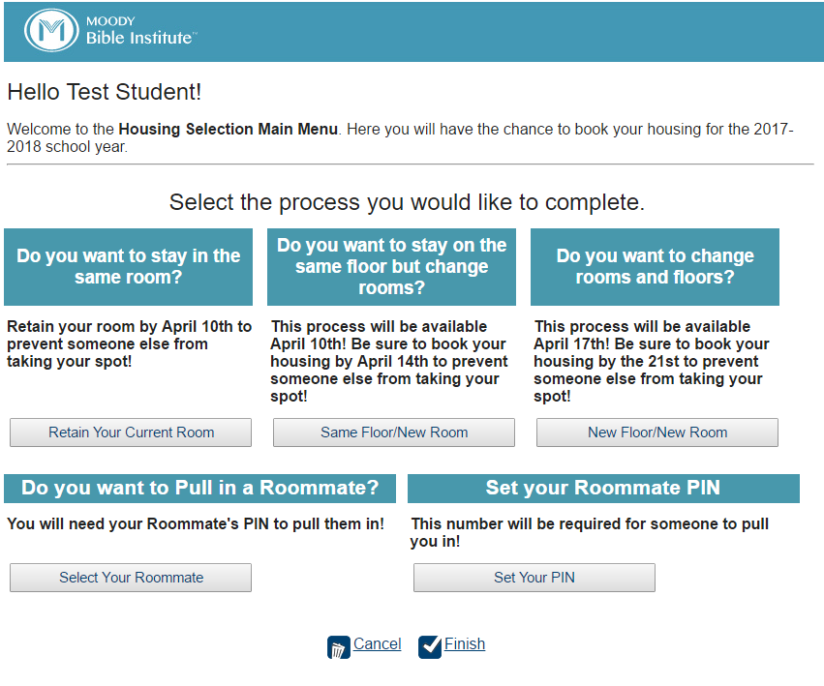
STEP 4: Confirm the Term Dates by clicking NEXT STEP 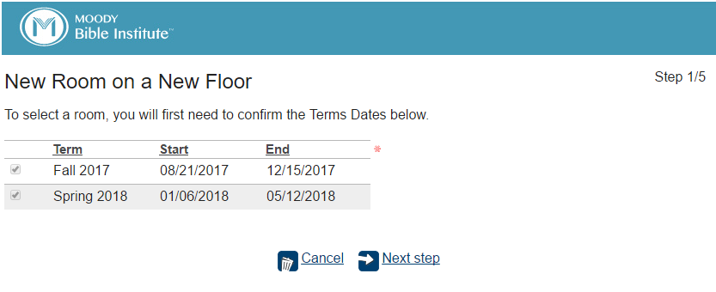

STEP 5: This step is not required. To skip this step, click NEXT STEP. To Select a Roommate, click the Green Plus Sign. Type in your Roommates First and Last name, or their ID, and click SEARCH. In order to select your roommate, you will need to input their Roommate PIN (CAPS apply). Then click SELECT and NEXT STEP.

STEP 6: Click the ROOM TYPE Dropdown Menu. This will show your options based on information you have input. If you input two roommates, you will only see Triple rooms available. If you input one roommate, you will only see Doubles.
Select the ROOM TYPE and click SEARCH.
Then click the links under AVAILABLE ROOMS BY LIVING AREA to show available options. To see additional details, you can click on the room.
To LOCK a bedspace, click the LOCK ICON. Then add each Roommate to a Bed-Space and click NEXT STEP.
STEP 7: Register for your meal plans, click the Green Plus Sign to see Plan Details. Then click Plan Type and select Meal. A list of meal plans will then become available in the Plan Drop down menu. To select a plan, click Add Meal Plan. This is required. Email Foodservice@moody.edu if you qualify for an exemption.

STEP 8: Review and Confirm. This process will not be complete until you click the FINISH button! You can also email or download a copy of your process summary for your records.

ROOMMATE PULL-IN
STEP 1: LOG IN FROM myMOODY PORTAL BY CLICKING ON CAMPUS HOUSING UNDER THE RESIDENCE LIFE HEADING

STEP 2: CLICK Housing Selection Main Menu in the center of the page.

STEP 3: Once you get to the Housing Selection Main Menu, click SELECT YOUR ROOMMATE.

STEP 4: To Select a Roommate/Roommate Group, click the Green Plus Sign. Type in your Roommates First and Last name, or their ID, and click SEARCH. In order to select your roommate, you will need to input their Roommate PIN (CAPS apply). Then click SELECT and NEXT STEP.

STEP 5: Confirm your Bed-Space and Term Dates by clicking NEXT STEP.
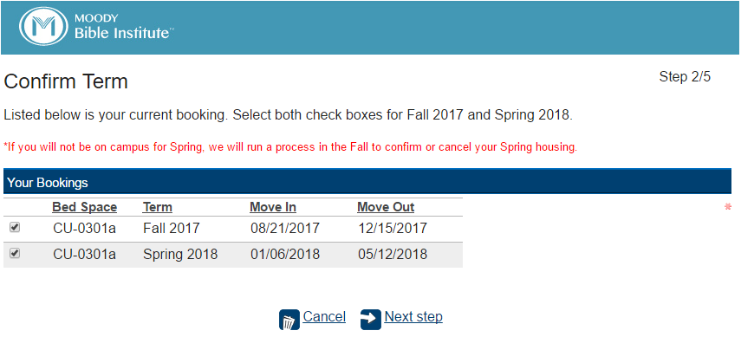
STEP 6: Book Your Roommates Bed-Space by clicking the Green Plus Sign. Add each Roommate to a Bed-Space and click NEXT STEP.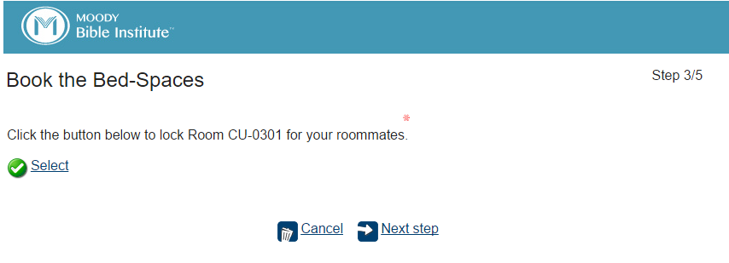

STEP 7: Register for your meal plans, click the Green Plus Sign to see Plan Details. Then click Plan Type and select Meal. A list of meal plans will then become available in the Plan Drop down menu. To select a plan, click Add Meal Plan. This is required. Email Foodservice@moody.edu if you qualify for an exemption. 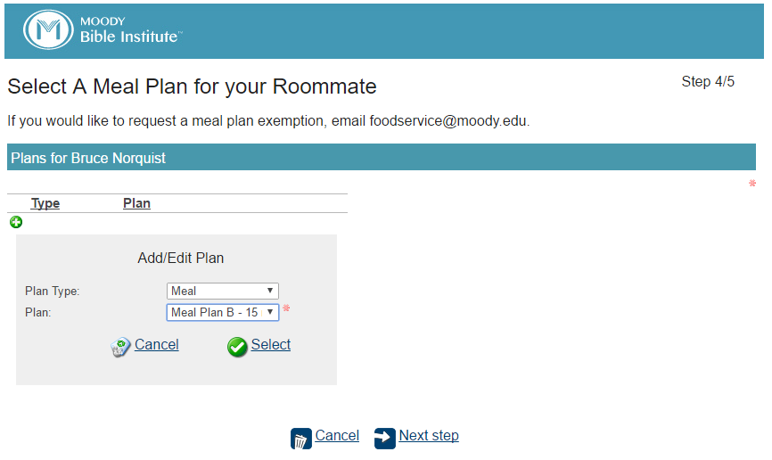

STEP 8: Review and Confirm. This process will not be complete until you click the FINISH button! You can also email or download a copy of your process summary for your records.

ROOMMATE PIN
STEP 1: LOG IN FROM myMOODY PORTAL BY CLICKING ON CAMPUS HOUSING UNDER THE RESIDENCE LIFE HEADING

STEP 2: CLICK Housing Selection Main Menu in the center of the page.

STEP 3: Once you get to the Housing Selection Main Menu, click SET YOUR PIN.

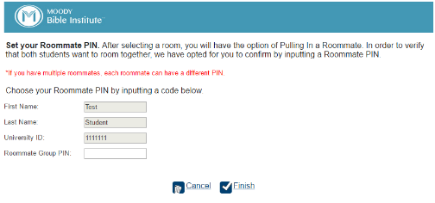
STEP 4: To set your PIN, Enter a password in the ROOMMATE GROUP PIN field. Be aware this is case sensitive. Then click FINISH to complete this process. If you forget your PIN, reset it by starting the process again. This code can be used by another student to pull you into their room.

